Exp No: 6
ARDUINO TO 16x2 LCD DISPLAY USING PROTEUS
AIM:
To write an Embedded C program to interface Arduino Uno and 16 x 2 LCD display using Arduino Uno and Proteus
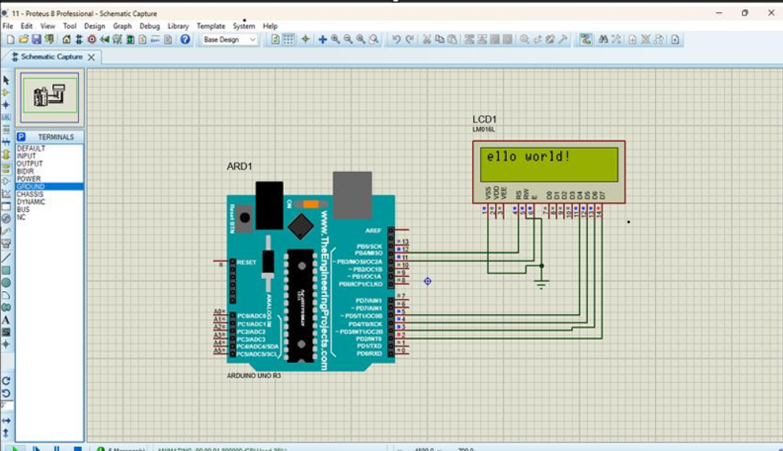

RESULT:
Thus the program has been successfully verified and executed

